Name – Gayatri Dnyaneshwar Avhad

Roll no- 231071007

Batch – A

Assignment -3

3

AIM: Write an algorithm to find gross and net salary of employees.

ABC co. ltd. has 2000 employees.

your task is to calculate each employees salary and find employee with

minimum salary and maximum salary.

Do the above task using divide and conquer technique.

Find the improvement in the complexity using divide

and conquer method.

ALGORITHM:

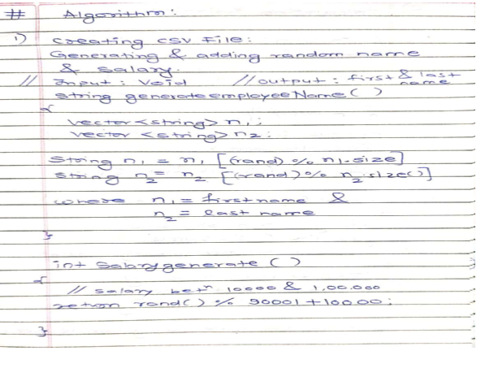

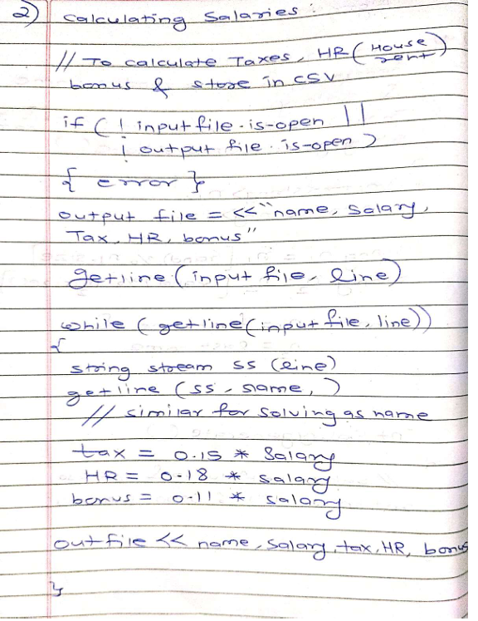

TIME COMPLEXITY:

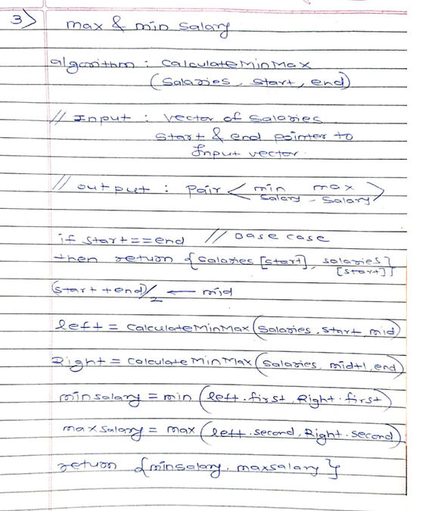

TIME Complexity:

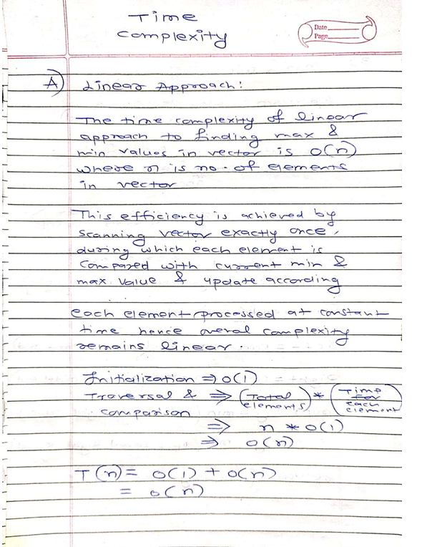

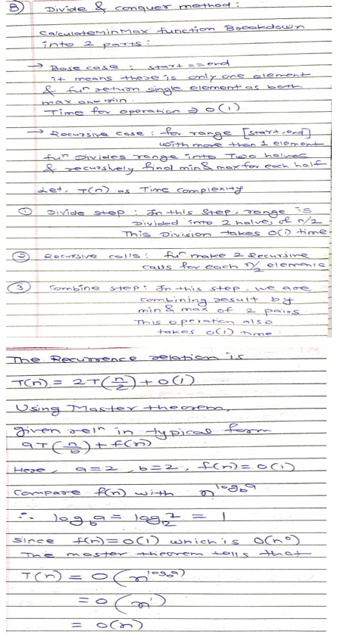

CODE:

1)CSV FILE GENERATOR:

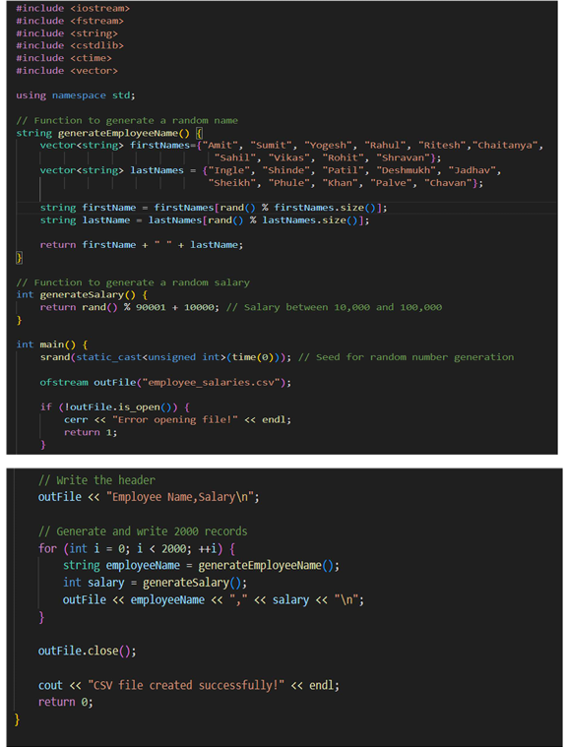

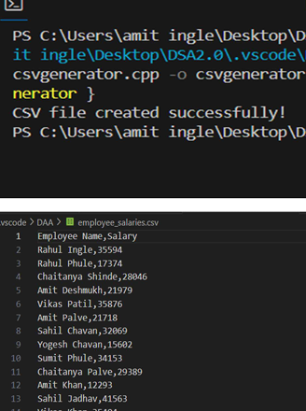

2)salary calculator:

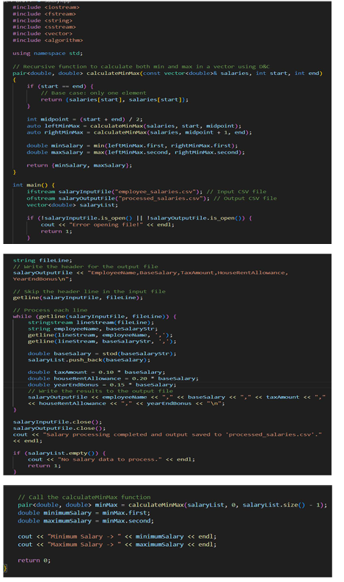

TEST CASES:

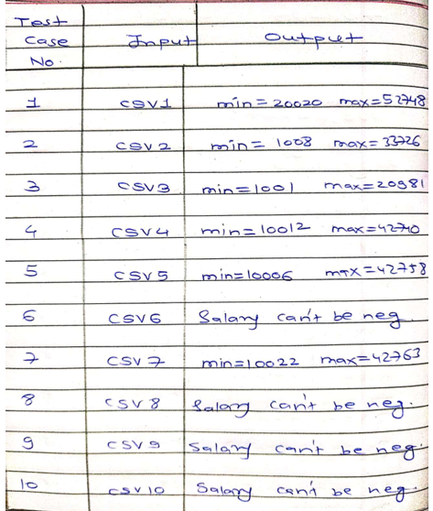

CALCULATION:

In this experiment, we calculated the gross and net salaries for 2,000

employees at ABC Co. Ltd., and iden fied those with the minimum and

maximum salaries using a divide-and-conquer approach. This method

divides the salary list into smaller segments, recursively computes the

minimum and maximum for each segment, and then combines the

results, achieving a me complexity of ( O(n) ). This is comparable to

the linear scan approach but offers benefits in modularity and

poten al paralleliza on. Although both methods have the same me

complexity, divide-and-conquer can be advantageous for handling

larger datasets or more complex problems efficiently